LAB 1: ADDITION

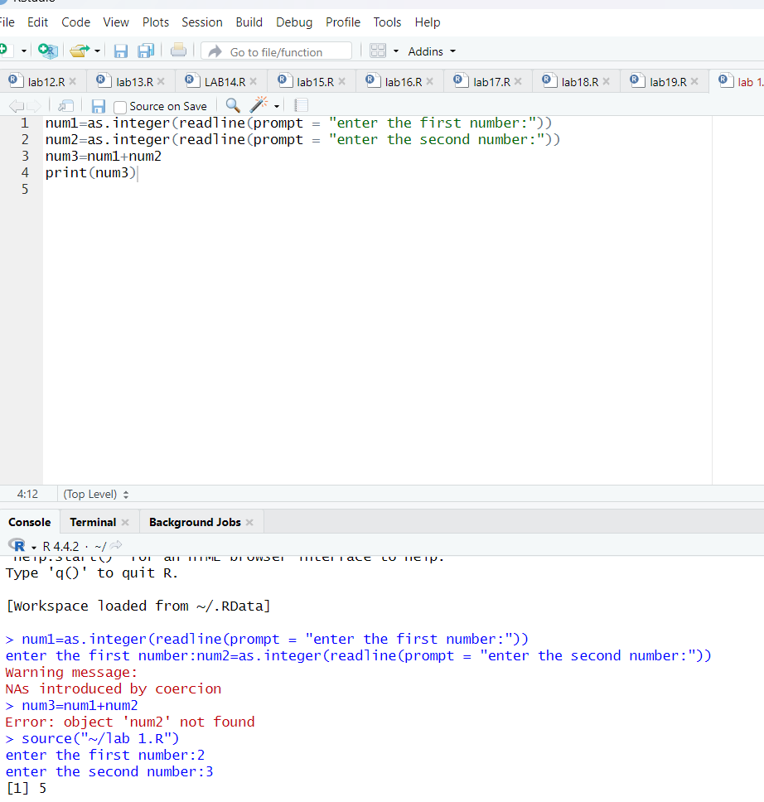

LAB 2 : SUBTRACTION

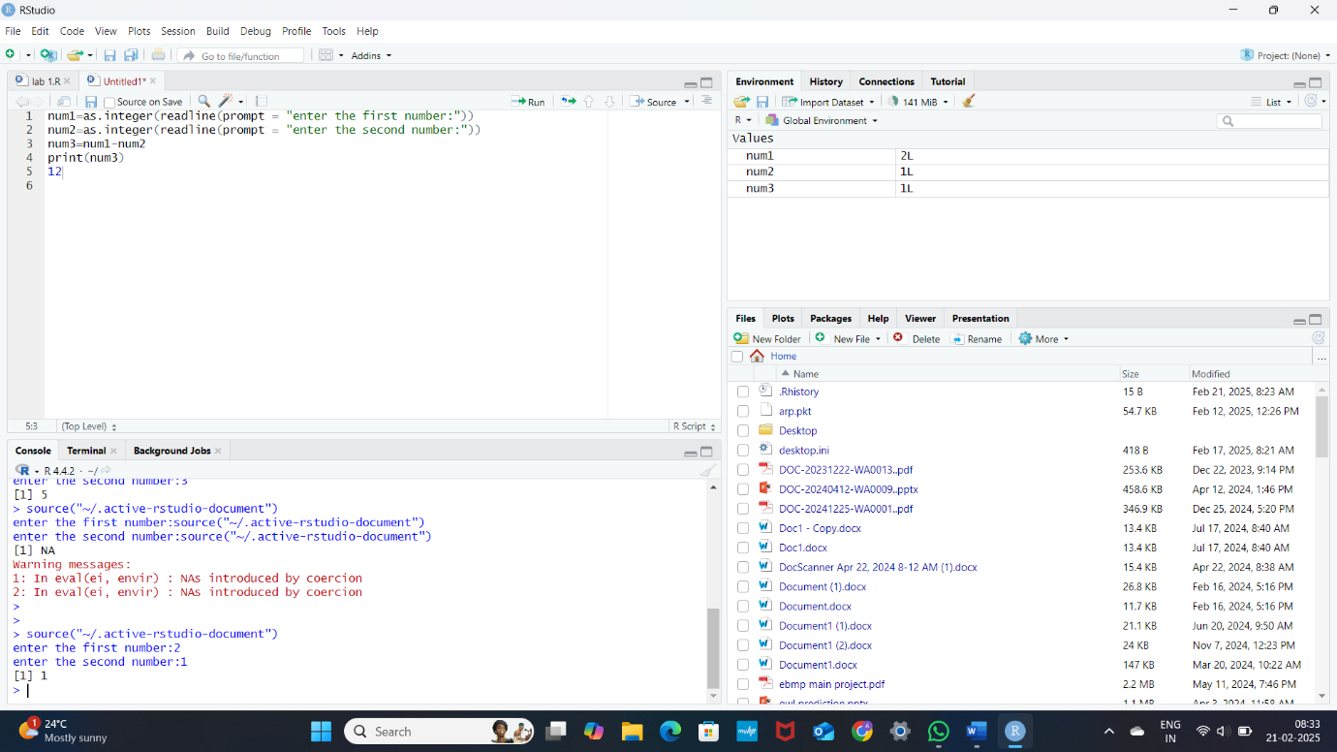

LAB 3 : MULTIPLICATION

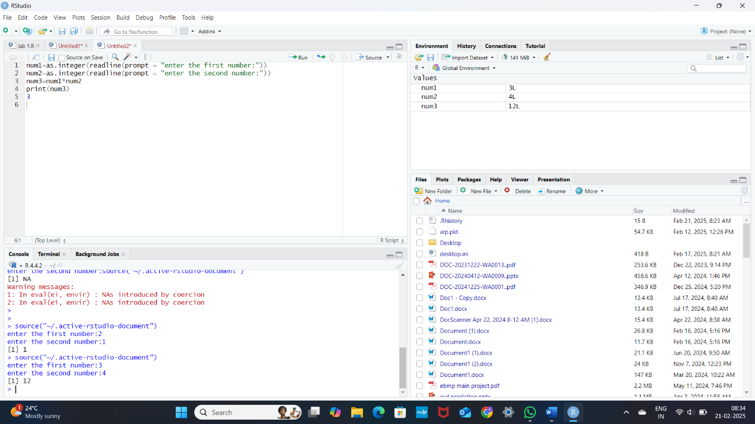

LAB 4 : DIVISION

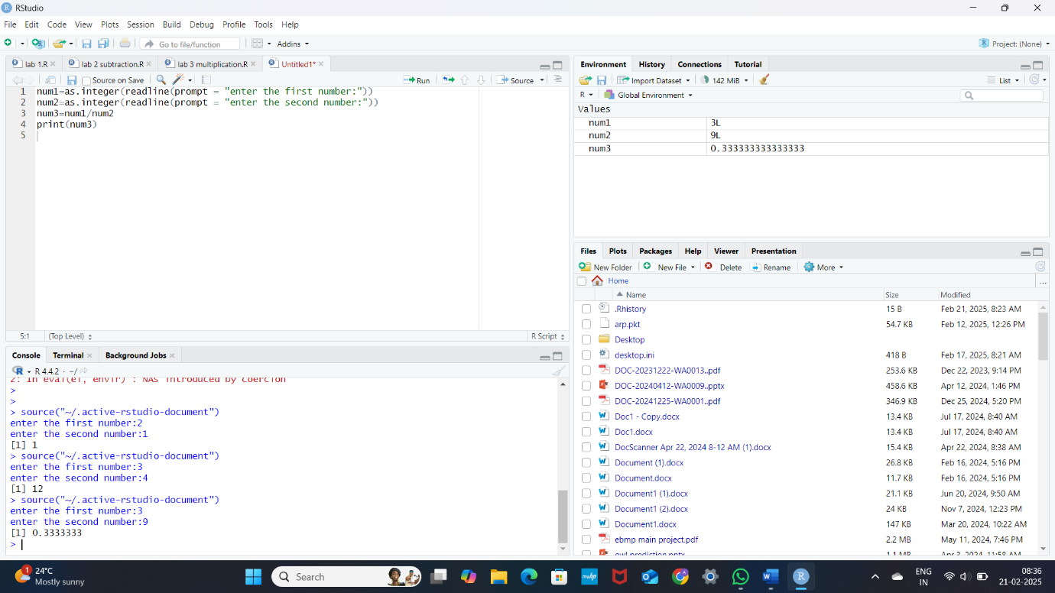

LAB 5: ODD OR EVEN

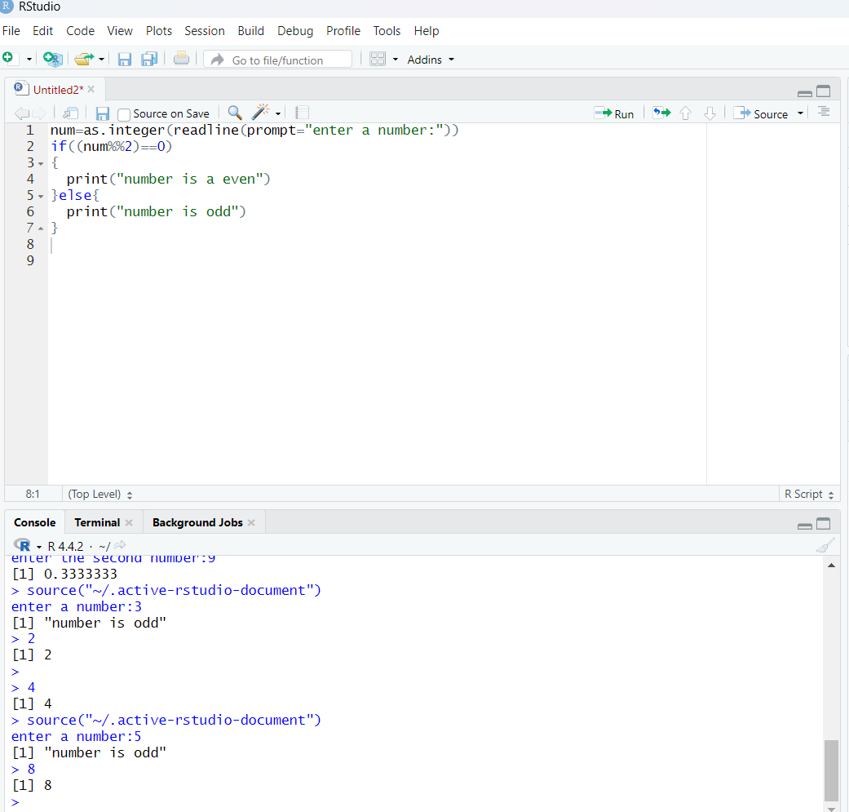

LAB 6: MEAN, MEDIAN, MODE

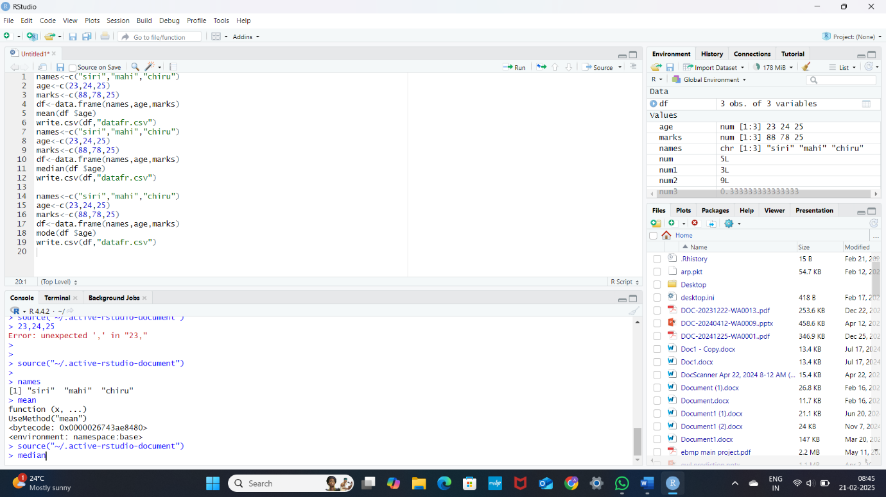

LAB7: SUMMARY

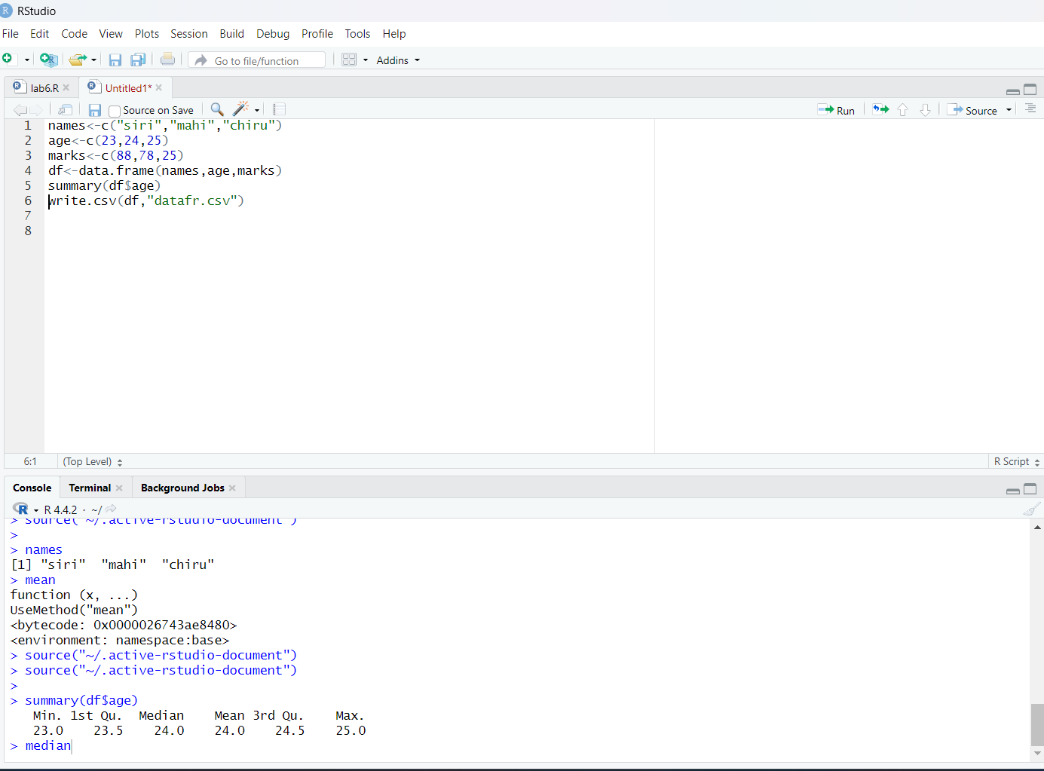

LAB 8: GREATEST AMONG 3 NUMBERS

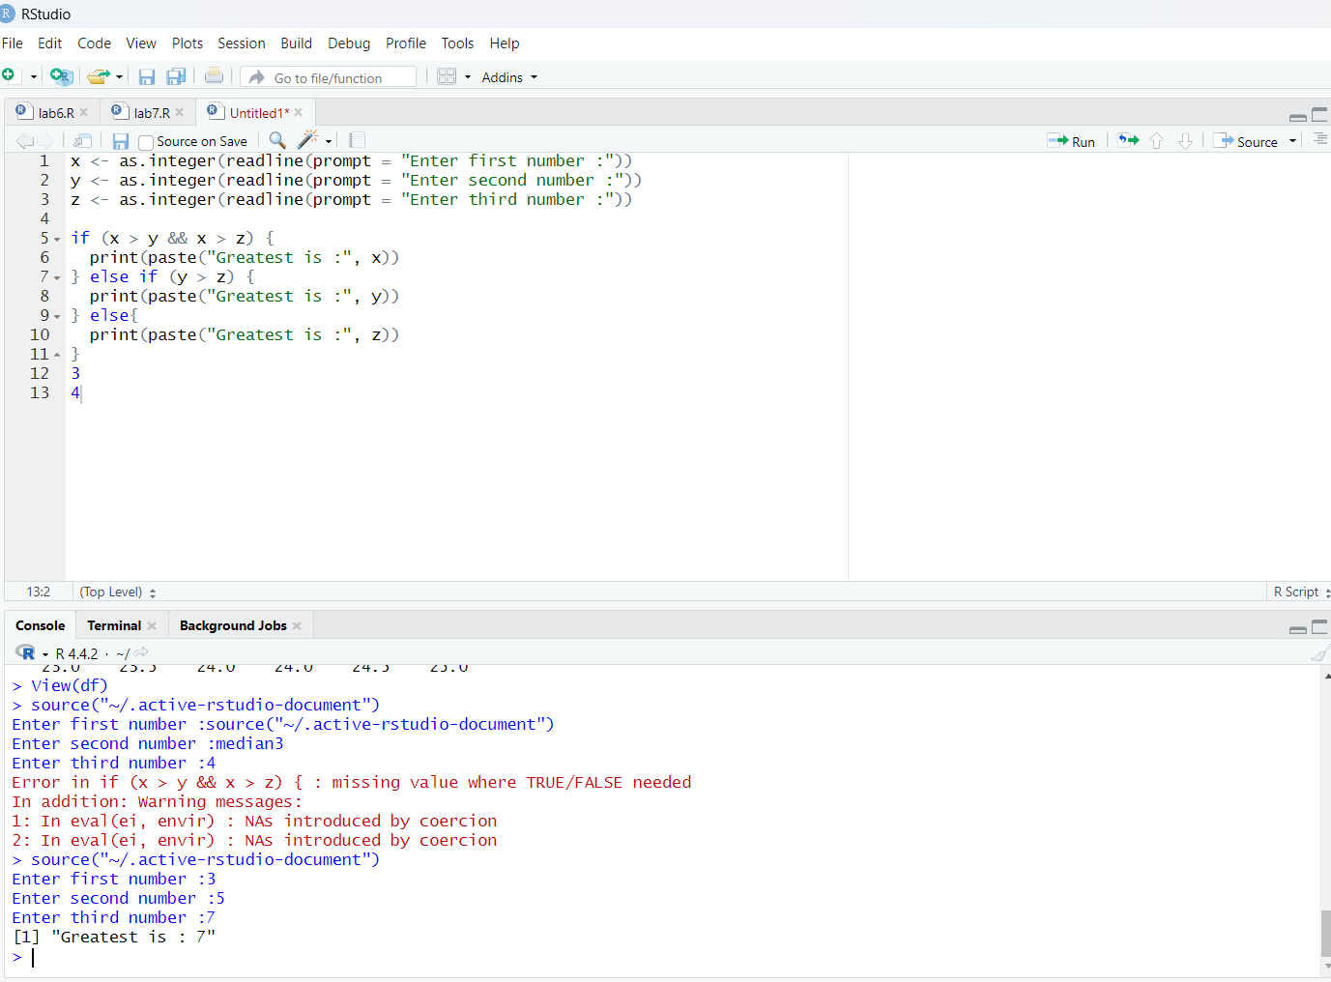

LAB 9: CENTRAL TENDENCY

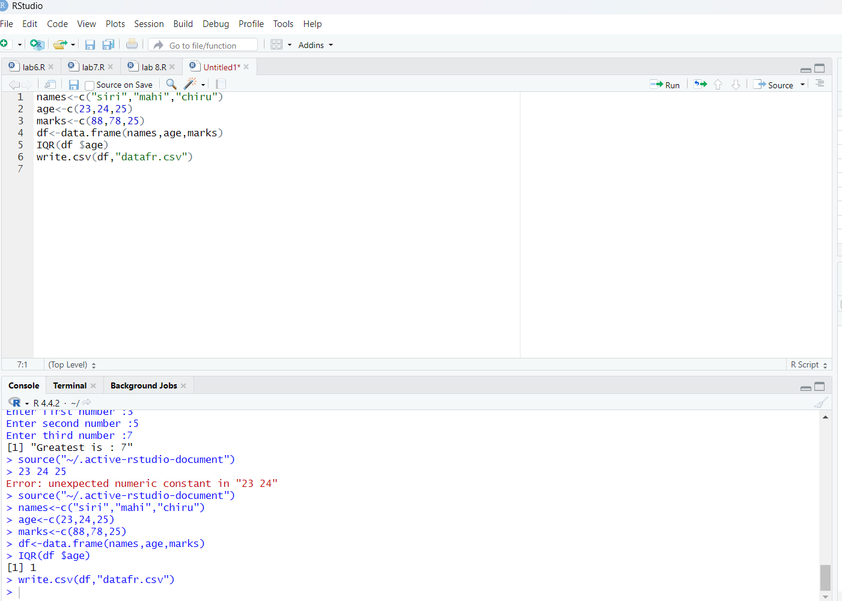

LAB10: QUANTILE

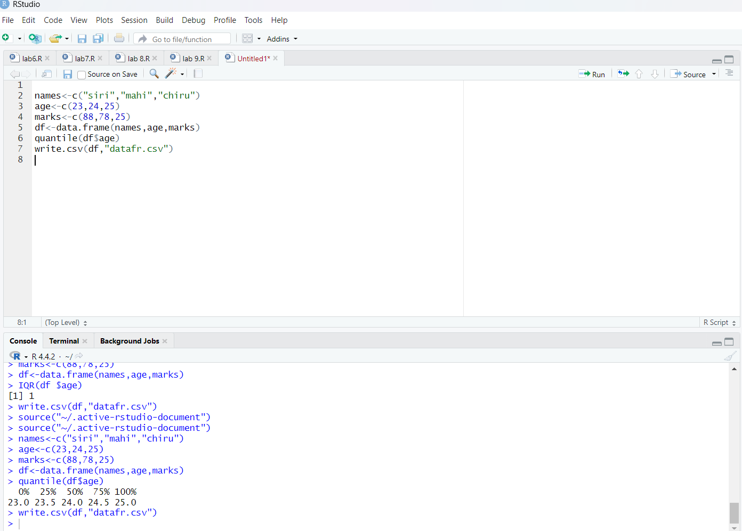

LAB 11: MIDRANGE

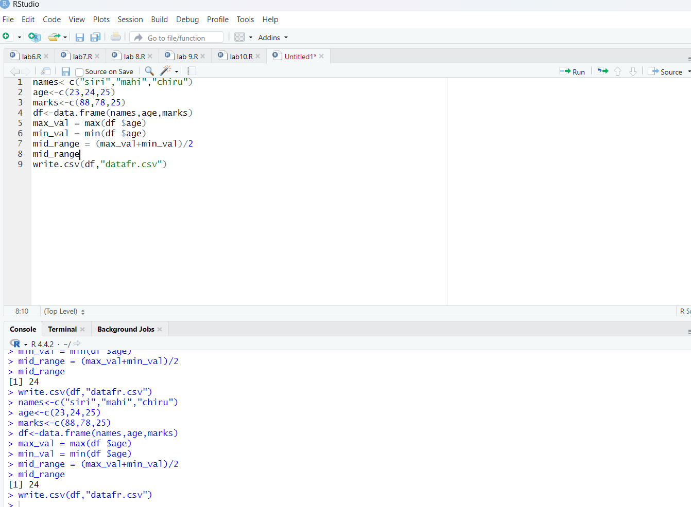

LAB 12: Z CORE

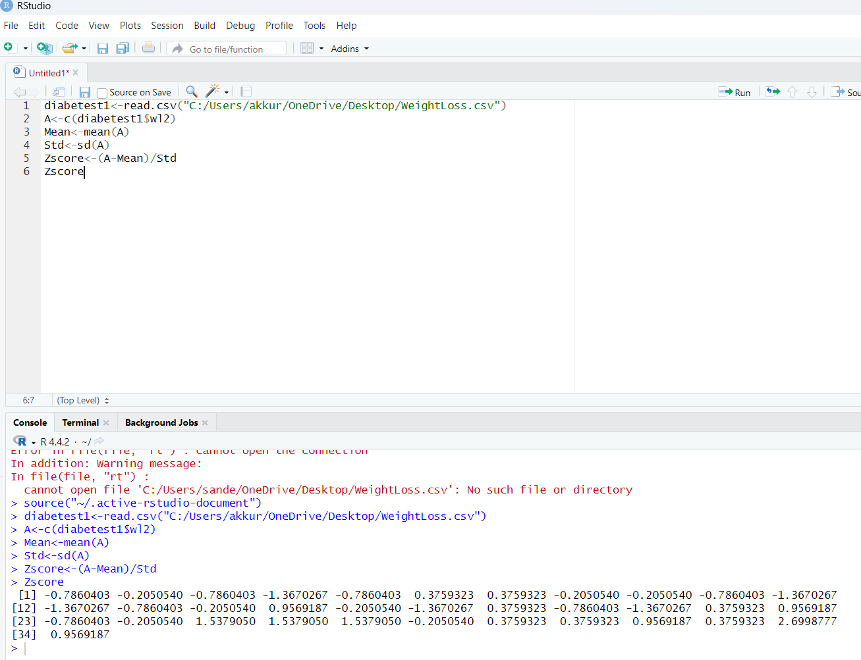

LAB 13: MIN MAX MEAN,MINMAX:

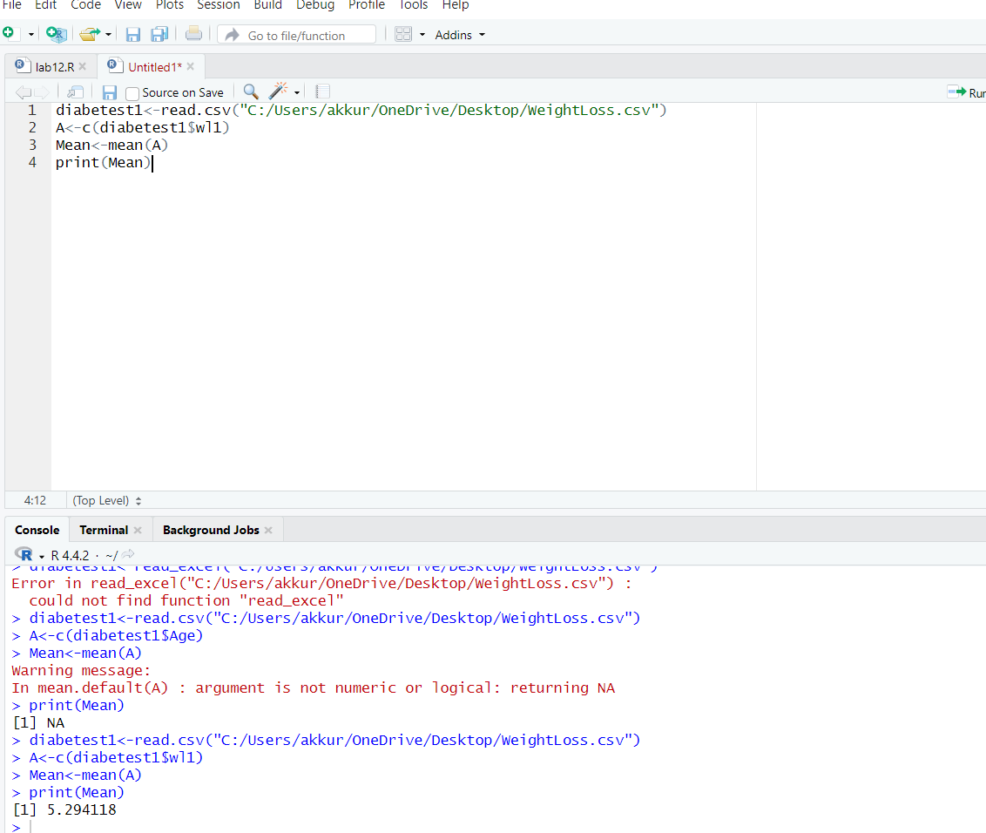

LAB 14: BAR PLOT AND HORIZONTAL BAR:

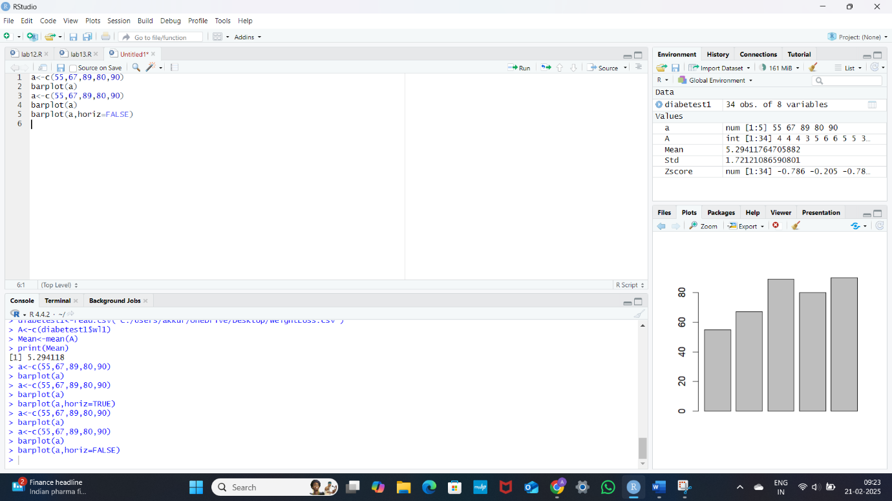

LAB 15: BOX PLOT:

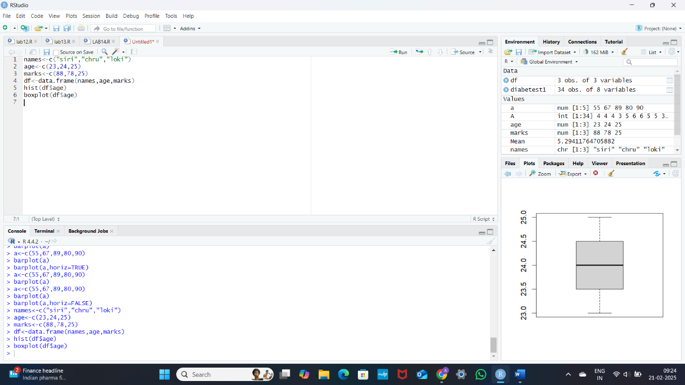

LAB 16: HISTOGRAM:

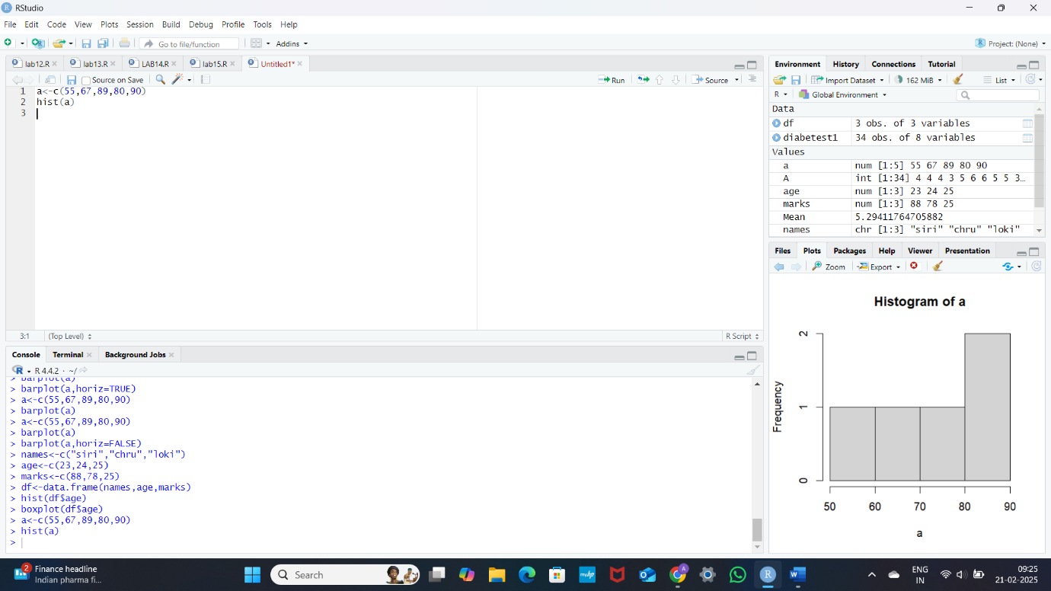

LAB 17: CORRELATION ANALYSIS:

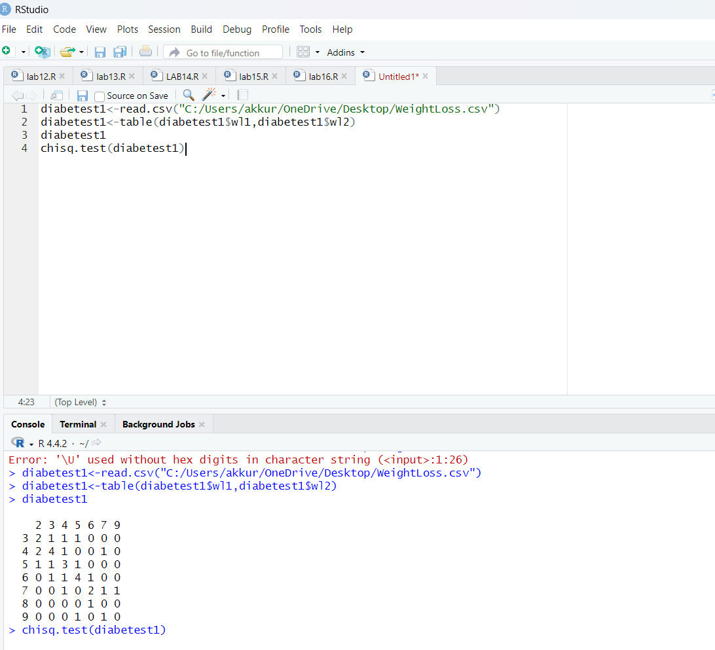

LAB18: SCATTER PLOT:

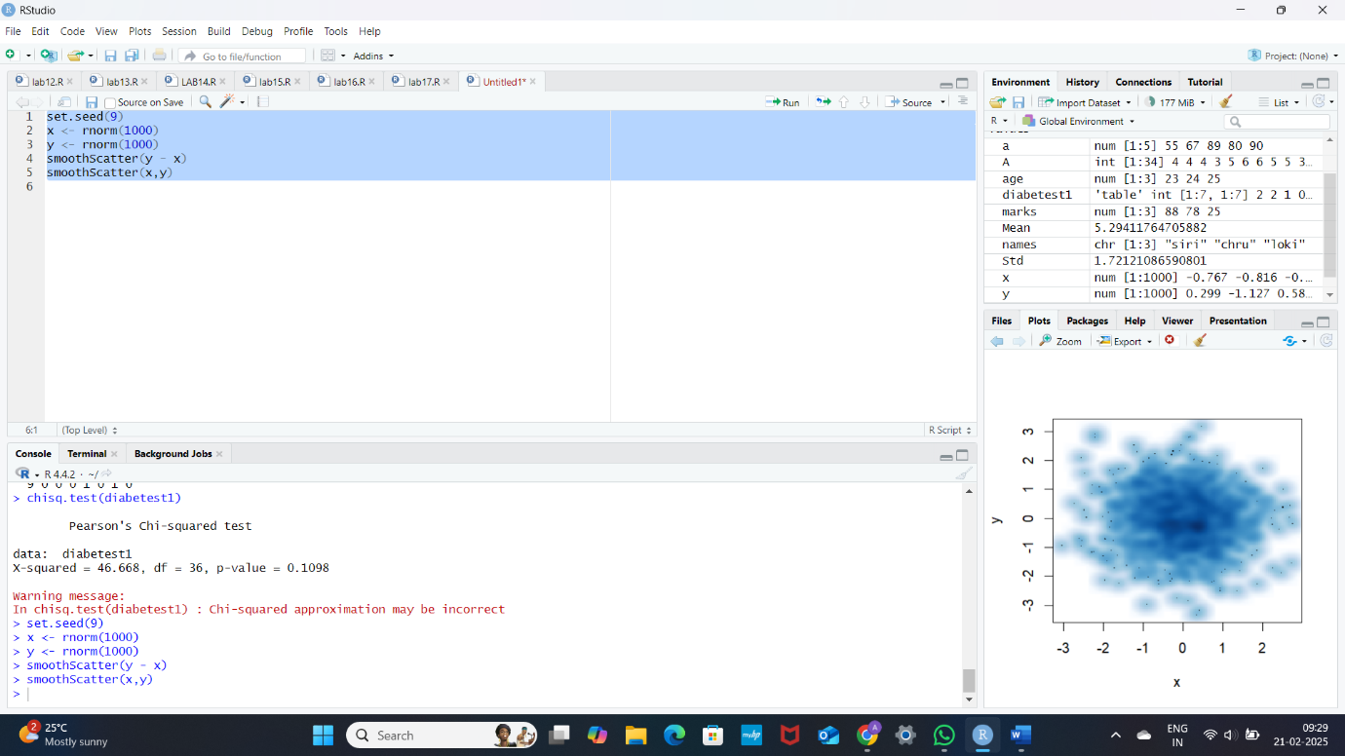

LAB 19: LINEAR REGRESSION:

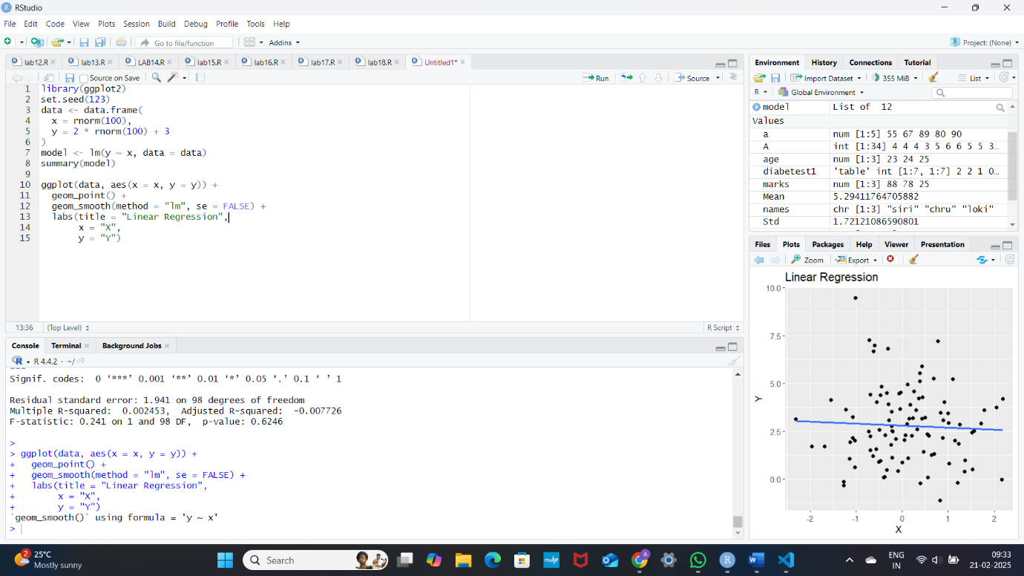

LAB 20: **MULTIPLE REGRESSION:**

